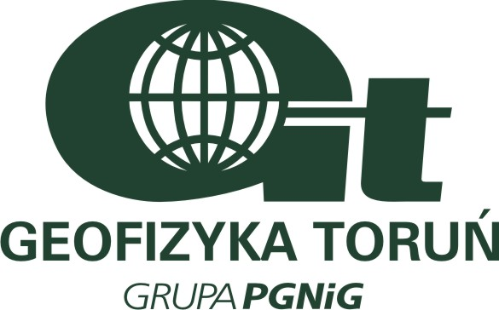
ANTI-BRIBERY & CORRUPTION POLICY



It is our policy to conduct all of our business in an honest and ethical manner. We take a zero-tolerance approach to bribery and corruption and are committed to acting professionally, fairly and with integrity in all our dealings wherever we operate. We will implement this policy through a comprehensive management system. This system will carry forward the general standards of business conduct set forth above and will direct our compliance procedures both internally and in our relations with customers and business partners.

1 Who is covered by the policy?
This policy applies to all individuals working at all levels and grades, including senior managers, directors, employees (whether permanent, fixed-term or temporary), consultants, contractors, and any other person providing services to us.

2 What is a Bribe/Corruption?
A bribe/corruption is a financial or other advantage offered or given:
- to anyone to persuade them to or reward them for performing their duties improperly or;
- to any public official with the intention of influencing the official in the performance of his duties.

3 Gifts and Hospitality
This policy does not prohibit giving and receiving promotional gifts of low value and normal and appropriate hospitality. However, in certain circumstances gifts and hospitality may amount to bribery and all employees must comply strictly with Domino’s ethics policy in respect of gifts and hospitality. We will not provide gifts or hospitality with the intention of persuading anyone to act improperly or to influence a public official in the performance of his duties.

4 Facilitation Payments and Kickbacks
We do not make, and will not accept, facilitation payments or “kickbacks” of any kind. Facilitation payments are typically small, unofficial payments made to secure or expedite a routine government action by a government official. Kickbacks are typically payments made in return for a business favour or advantage. All employees must avoid any activity that might lead to, or suggest, that a facilitation payment or kickback will be made or accepted by us.

5 Donations
We do not make contributions of any kind to political parties. No charitable donations will be made for the purpose of gaining any commercial advantage.

6 Record Keeping
We will keep financial records and have appropriate internal controls in place which will evidence the business reason for making any payments to third parties.

7 Raising Concerns
Employees will be encouraged to raise concerns about any issue or suspicion of malpractice at the earliest possible stage. No employee will suffer any detriment as a result of raising genuine concerns about bribery, even if they turn out to be mistaken.

9 Monitoring
The effectiveness of this policy will be regularly reviewed by the Board. Internal control systems and procedures will be subject to audit under the internal audit process.

Piotr Antonik
President, CEO Toruń, 1.07.2015

